

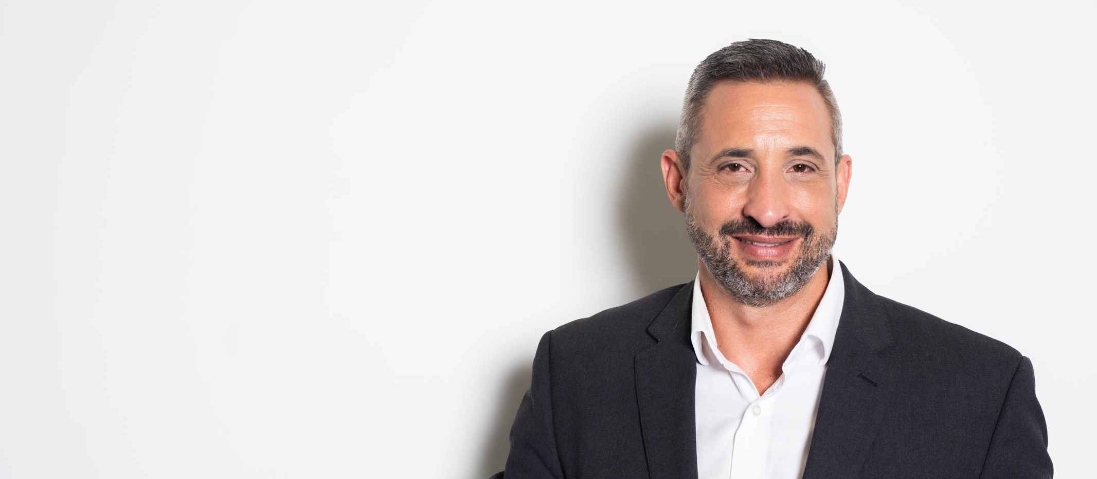
SHORT BIO
Dr Gavriel (Gav) Schneider is a globally recognized expert in risk management, security, leadership, and resilience, with a unique blend of frontline and senior leadership experience, business acumen, and a strong academic foundation. An award-winning leader, martial artist, and author, Dr Gav has developed the groundbreaking Presilience® approach to thriving in today’s complex and digital world which he has used to 10x his own business and help many others. His dynamic presentations combine deep expertise with actionable insights, leaving audiences inspired and equipped to face the challenges of our fast-paced, ever-changing environment.

LONGER BIO
Dr Gavriel (Gav) Schneider stands out as the speaker of choice due to his extensive expertise in risk management, executive leadership, and resilience, complemented by a unique blend of frontline experience and academic credentials. As an award-winning business and thought leader as well as a martial artist with a 9th-degree black belt, Gav has developed the innovative Presilience® approach, which equips individuals and organizations to thrive in today’s complex, fast-paced environment. His methodology has successfully transformed businesses, including his own, where he achieved remarkable growth and team cohesion. Gav’s dynamic presentations are informed by real-world experiences and rigorous research, ensuring that audiences receive practical, actionable insights.
His ability to connect with diverse audiences—from corporate executives to students—makes him a versatile and engaging speaker. Gav has delivered keynotes and workshops to a range of organizations, including global giants like Google, government departments and blue-chip corporations. His focus on blending education with motivation leaves attendees inspired and equipped with strategies that can be immediately applied. This adaptability to tailor his message based on the audience's needs ensures that each session resonates deeply, providing significant value and fostering a culture of resilience and proactive decision-making.
Moreover, Gav's commitment to continuous improvement and risk intelligence is crucial in today’s ever-evolving landscape. By emphasizing the importance of understanding human behavior and cultivating a strong risk culture, he empowers teams to navigate challenges effectively. His approach not only addresses the complexities of risk management but also highlights opportunities for growth and innovation, making him an invaluable asset for organizations seeking to enhance their performance and resilience in a VUCAD (Volatile, Uncertain, Complex, Ambiguous and Digital) world.

